Date: 18.09.2017
PRODUCT DATA SHEET
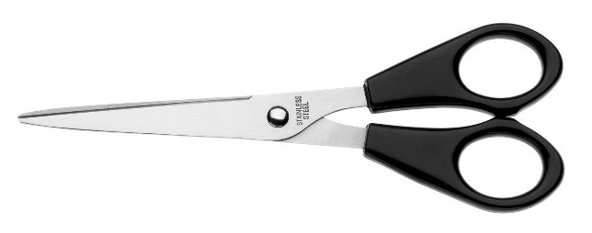 | Item number:
 | E-34160 BP
 | Brand Name:
 | Buero Scissor
 | Description:
 | Buero scissors, recycled plastic handle, 14,8cm/6", black

PRODUCT INFORMATION
Colour: | Blade material:
Black | Stainless steel
Full length: | Handle material:
148 mm/ 6”, | Plastic
Shape of tip: | Product Weight
pointed | 0,024 kg
Product Origin | Poly bag weight
China | 0,001 kg
Customs tariff number: | -
82130000 | -

LOGISTIC INFORMATION
Single packaging | Single Weight | Single Measures | Unit
Poly bag with sticker | 0,025 kg | 16 x 7 x 1 cm | 1
Inner packaging | Inner Weight | Inner easures | Units by box
Carton box | 0,26 kg | 18,5 x 4 x 6 cm | 10
Master packaging | Master Weight | Master Measures | Units by box
Carton box | 6,4 kg | 26x 18,5 x 26,5 cm | 240
EAN Single: | 4027521341609
EAN Inner: | 34027521341600
EAN Master: | 54027521341604

MARKETING TEXT
The scissors guarantee precise cuttings by the stainless steel blades. Additional comfort during cutting is offered by the ergonomic shaped, black plastic handles, which enable a very comfortable and precise working

