Date: 22.06.2018
PRODUCT DATA SHEET
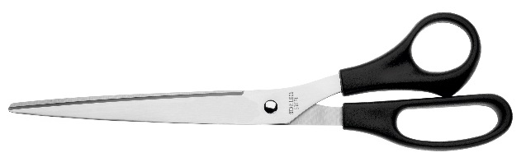 | Item number:
 | E-34111 BP
 | Brand Name:
 | Buero Scissor
 | Description:
Buero scissors, recycled plastic handle, 25,0cm/10",
black

PRODUCT INFORMATION
Colour: | Blade material:
Black | Stainless steel
Full length: | Handle material:
250 mm/ 10”, | Plastic
Shape of tip: | Product Weight
pointed | 0,067 kg
Product Origin | Poly bag weight
China | 0,001 kg
Customs tariff number: | -
82130000 | -

LOGISTIC INFORMATION
Single packaging | Single Weight | Single Measures | Unit
Poly bag with sticker | 0,068 kg | 29 x 10 x 1 cm | 1
Inner packaging | Inner Weight | Inner easures | Units by box
Carton box
Master packaging | Master Weight | Master Measures | Units by box
Carton box | 17,10 kg | 77 x 36 x 18 cm | 240
EAN Single: | 4027521341111
EAN Inner:
EAN Master: | 54027521341116

MARKETING TEXT
The scissors guarantee precise cuttings by the stainless steel blades. Additional comfort during cutting is offered by the ergonomic shaped, black recycled plastic handles, which enable a very comfortable and precise working

